SQL Developer
Task 4 - Documentation and Queries
Window Functions Analysis Using Existing Students Table
📋 Project Overview
This project focuses on using SQL window functions to rank students and perform cumulative analysis using the existing Students table structure and data.

Task Queries Using Window Functions
Task 1: Rank Students Based on Total Scores
sql
-- Task 1: Rank Students by Total Scores using RANK()
SELECT
studentid, name,grade, mathscore,sciencescore, englishscore,
(mathscore + sciencescore + englishscore) as TotalScore,
RANK() OVER (ORDER BY (mathscore + sciencescore + englishscore) DESC) as score_rank
FROM
students
ORDER BY
TotalScore DESC;
Output:
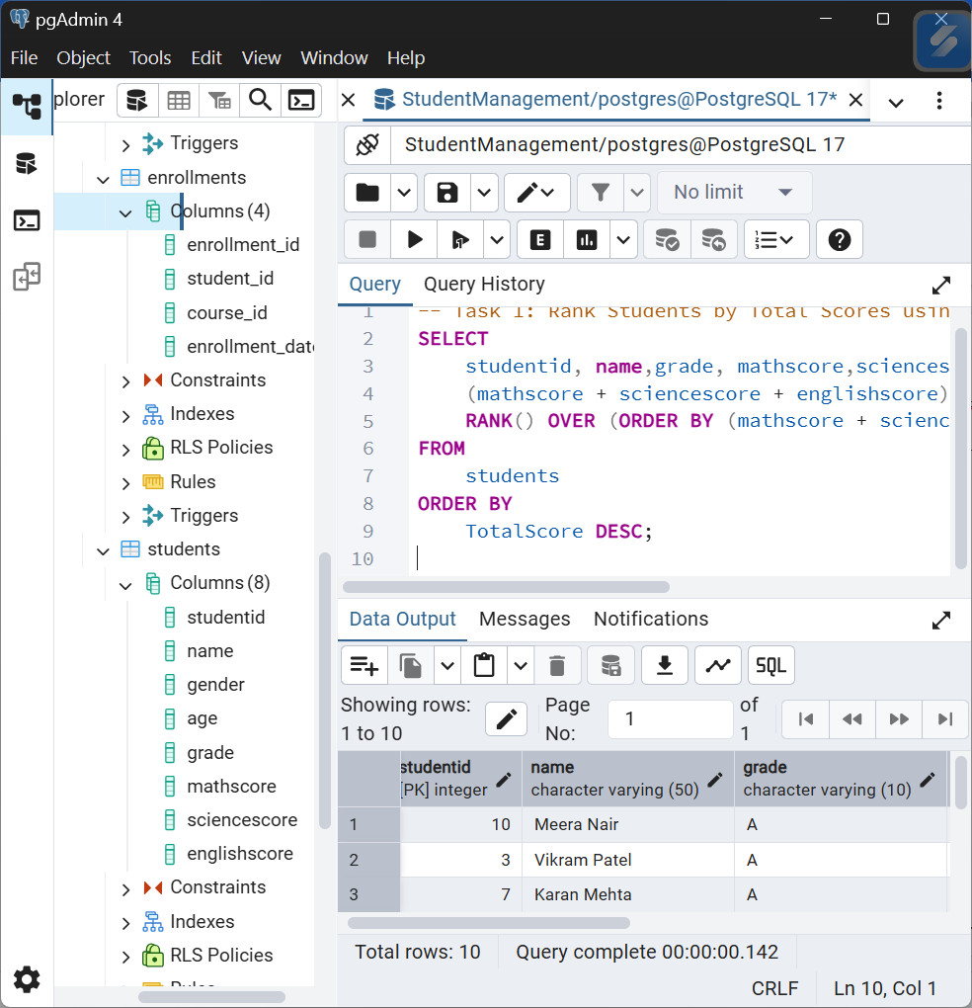
Task 2: Calculate Running Totals for Math Scores
sql
-- Task 2: Running Total of Math Scores ordered by StudentID
SELECT
studentid,
name,
mathscore,
SUM(mathscore) OVER (ORDER BY studentid) as running_total_math,
AVG(mathscore) OVER (ORDER BY studentid) as running_avg_math,
COUNT(*) OVER (ORDER BY studentid) as running_count
FROM
students
ORDER BY
studentid;

Output:
